Battery Installation & Removal Instructions
For Milwaukee M18 (18–48 V) Battery

⚠️ Important Safety Information
• Your Check N Tow operates only with the battery style you selected at purchase.
• To use a different battery brand (e.g., DeWalt, Snap-On), you must purchase the appropriate adapter designed for that battery type.
• Always power off the unit before inserting or removing the battery.
• Use care to avoid bending contacts or forcing the connection.

🔧 Installing the Battery
1. Align the Battery: Position the Milwaukee M18 battery with the connector rails facing the slot on your Check N Tow.
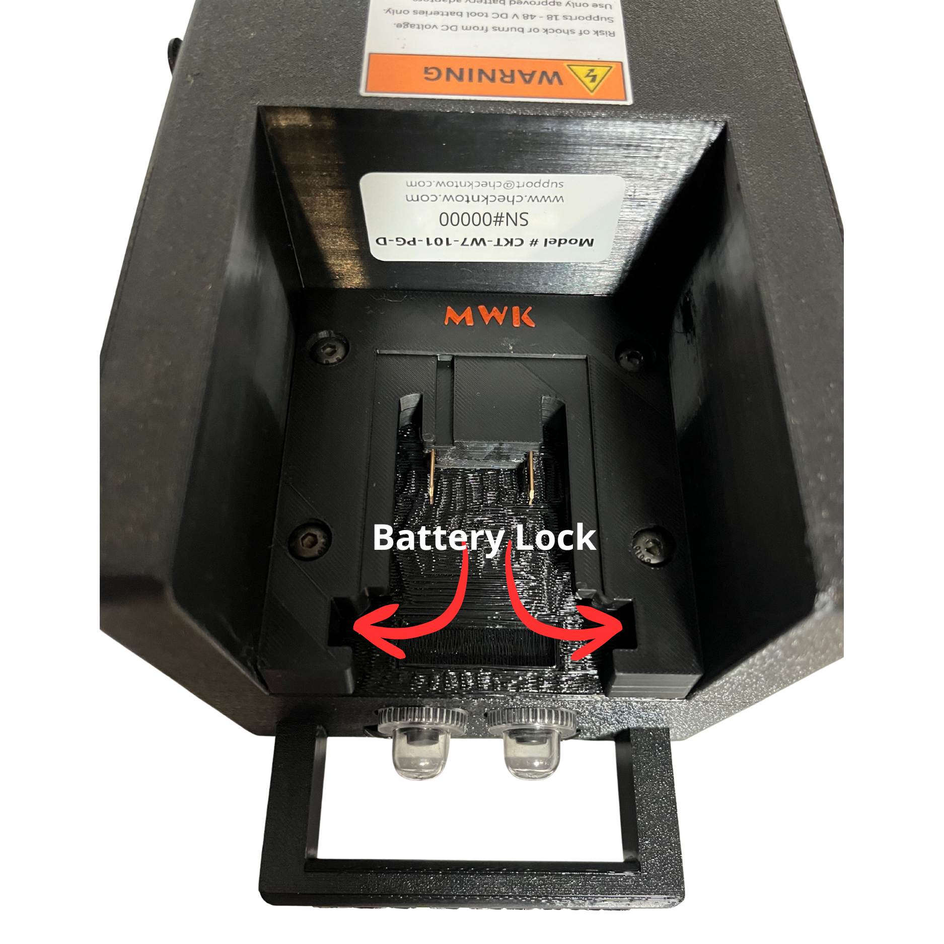
Figure 1 – Battery lock mechanism

2. Slide Into Place: Gently slide the battery along the rails until it clicks and locks into position.
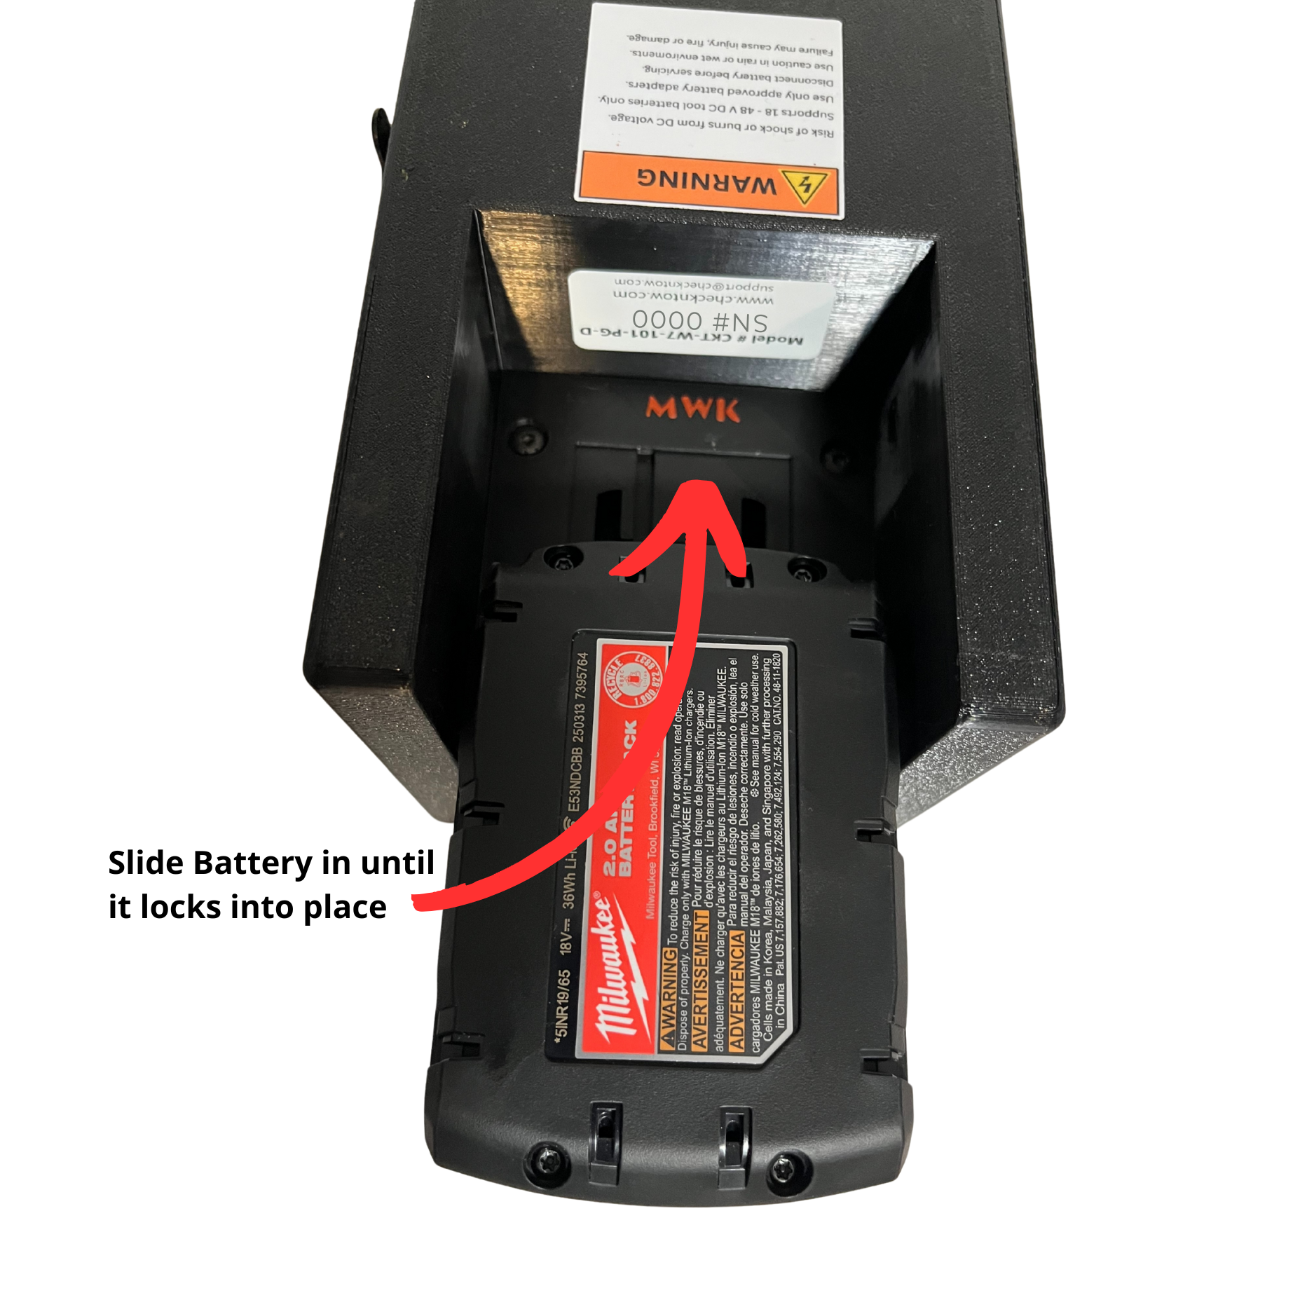
Figure 2 – Sliding the battery into place

3. Verify Connection: Check that the battery is seated firmly and cannot move freely. If resistance is felt, remove and re-align before reinserting. Do not force the battery—light pressure should be enough.

🔄 Removing the Battery
1. Power Off: Ensure the Check N Tow is turned off.
2. Release the Locks: Press and hold both red release tabs on the Milwaukee M18 battery simultaneously.

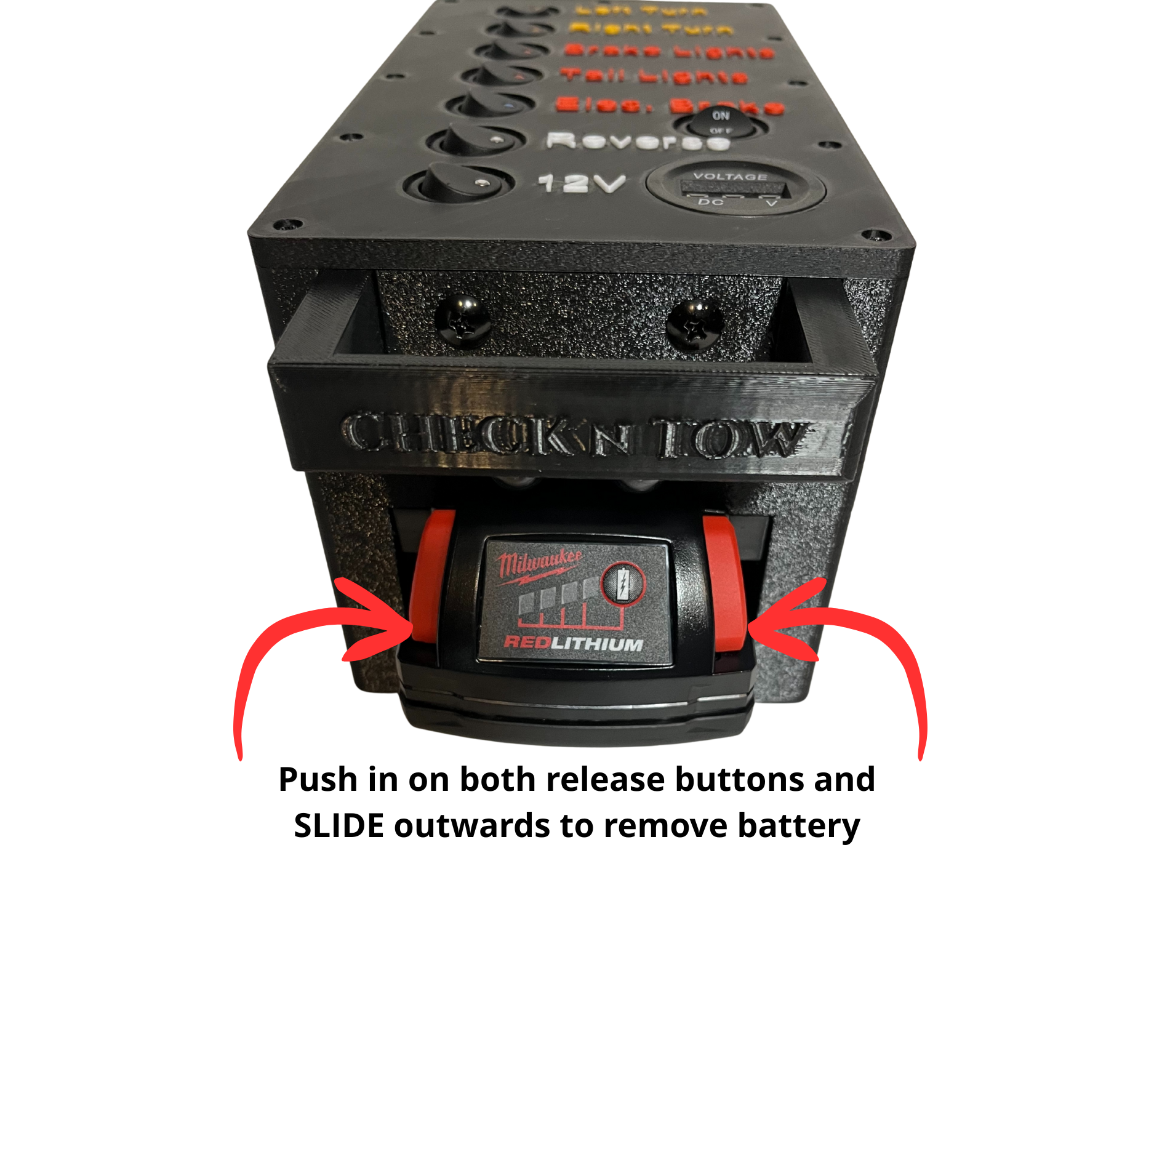
Figure 3 – Press release tabs and slide battery out

3. Slide Out: While holding the tabs, pull the battery straight out from the connector slot.
4. Inspect and Store: Inspect terminals for debris or corrosion and store the battery in a cool, dry location away from direct sunlight.

